
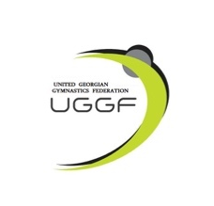

Rhythmic Gymnastics International Tournament
PAZHAVA CUP 2026
Tbilisi, Georgia
May 15 - 17, 2026

Form to be sent to:
Organizing Committee / Host Federation
Phones of organizers: Tel: +995 571 88 81 30 Salome Pazhava
e-mail: pazhavacup@gmail.com
IMPORTART: Payments and bank account:
BEN'S Account: GE73TB7264936180100004
SWIFT: TBCBGE22
Deadline: 1 March, 2026

Definitive registration

Federation |  | Contact person:
Federation |  | Phone:
Federation |  | E-mail:

 | FIG  (all categories) |  |  | Total
Judge(s)
Coach( es)
Gymnasts

Place and date | Seal of the NF | NF authorised signature
 |  | Signature of the President or Secretary General of the participating FIG affiliated NF

