

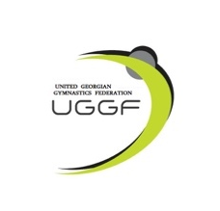
Rhythmic Gymnastics International Tournament
PAZHAVA CUP 2026
Tbilisi, Georgia
May 15 - 17, 2026

Form to be sent to:
Organizing Committee / Host Federation
Phones of organizers: Tel: +995 571 88 81 30 Salome Pazhava
e-mail: pazhavacup@gmail.com
IMPORTART: Payments and bank account:
BEN'S Account: GE73TB7264936180100004
SWIFT: TBCBGE22

Deadline: 10 April, 2026

Nominative registration

Federation |  | Contact person:
Federation |  | Phone:
Federation |  | E-mail:

Gymnasts-SENIOR Individual Competition
First name | Family name | Date of birth | Gymnasts FIG License

Gymnasts – JUNIOR Individual Competition

First name | Family name | Date of birth | Gymnasts FIG License

Gymnasts – SENIOR Groups Competition

First name | Family name | Date of birth | Gymnasts FIG License

Gymnasts – JUNIOR Groups Competition

First name | Family name | Date of birth | Gymnasts FIG License

AGE CATEGORY Non-gymnast participants
First name | Family name | Date of birth | Category

 | Name, Surname | Number of persons Judge(s) | Judge (s) FIG Brevet
coach(es)

judge(s)

additional person(s)

Place and date | Seal of the NF | NF authorised signature
 |  | Signature of the President or Secretary General of the participating FIG affiliated NF

