
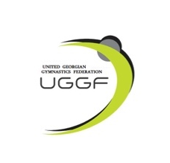

Rhythmic Gymnastics International Tournament
PAZHAVA CUP 2026
Tbilisi, Georgia
May 15 - 17, 2026

Form to be sent to:
Organizing Committee / Host Federation
Phones of organizers: Tel: +995 571 88 81 30 Salome Pazhava
e-mail: pazhavacup@gmail.com
IMPORTART: Payments and bank account:
BEN'S Account: GE73TB7264936180100004
SWIFT: TBCBGE22

Deadline: 10 April, 2026
Travel Schedule Form

Federation |  | Contact person:
Federation |  | Phone:
Federation |  | E-mail:
If the team delegation is scheduled on more than one transportation mean, please complete one (1) form for
each transportation mean. For earlier arrival or later departure please contact the OC.
Arrival information
# of persons |  |  | # of luggage
Date: |  |  |  |  | Arrival time
By airplane | Airport: |  |  | Flight # |  | From
By train | Station: |  |  | Train # |  | From
By car

Departure information
# of persons |  |  | # of luggage
Date: |  |  |  |  | Departure time
By airplane | Airport: |  |  | Flight # |  | To
By train | Station: |  |  | Train # |  | To
By car

Local transport cost | Number  at XXX/person |  | Total

Place and date | Seal of the NF | NF authorised signature
 |  | Signature of the President or Secretary General of the participating FIG affiliated NF

